

**RAPE DETECTION AND PREVENTION SYSTEM USING IOT AND MACHINE LEARNING**

**NJOROGE ESTHER WAMBUI: 102008**

**SUPERVISOR: JAMES GIKERA**

An information system project proposal submitted to the faculty of information technology in partial fulfilment of the requirements of the award of a degree in Information and Computer science.

Date of submission: 23 June 2020

# Declaration

I declare that this project has not been submitted to any other university for the award of Bachelor of Science informatics degree

Student Name: Njoroge Esther Wambui

Admission Number: 102008

Signature …………… Date…………………

I certify that this work is being submitted for examination with my approval.

Supervisor name: James Gikera

Signature …………… Date………………

# Abstract

***Keywords: IOT, Gender Based Violence, Machine Learning.***

*Gender based violence is a recurrent predominant issue in the society. There are actions that have been taken to suppress the situation but most of them incline to be unsuccessful.*

*Women tend to be easily targeted when they are alone or highly intoxicated. Thereafter, the victim may try to reach out to people or report the incident to the police, but the response time tends to be long and the reported case may not be treated with the seriousness it deserves due to factors like lack of evidence or unclear reports by the victim.*

*The aim of this project is to reduce response time by reaching out to a number of people at once, provide evidence of physical struggle and possibly prevent the abuse from occurring. The proposed system is in two segments IOT and Machine Learning. The IOT will include sensors to check the pulse rate, GSM and GPS modules that will facilitate communication with the selected contacts and the Machine Learning segment: creating a model that will be used to detect any signs of physical struggle and later a report will be generated with regards to the data collected. The report may be used for evidence.*

# Table of Contents

Declaration ii

Abstract iii

Table of Contents iv

Table of Figures v

Chapter 1: Introduction 1

1.1 Background 1

1.2 Problem Statement 2

1.3 Aim 2

1.3.1 Specific Objectives 2

1.3.2 Research questions 3

1.3 Justification 3

1.5 Scope and Limitation 3

Chapter 2: Literature Review 5

2.1 Introduction 5

2.2 Struggles experienced by victims during assault. 5

2.3 Technologies Used 5

2.3.1 IoT 5

2.3.2 Machine Learning 7

2.4 Related Applications 8

2.4.1 ATHENA 8

2.4.2 Watch Over Me 9

2.4.3 Safecity 10

2.4.4 React Mobile app 11

2.4.5 Prevention Education 12

2.4.6 SHE‐ Society Harnessing Equipment (IoT) 13

2.5 Gaps in Existing Systems 14

2.6 Conceptual Diagram 14

References 15

Appendix 17

# Table of Figures

Figure 2. 1: GPS and GSM module 7

Figure 2. 2: Decision Boundary 8

Figure 2. 3: ATHENA 9

Figure 2. 4: Watch Over Me 10

Figure 2. 5: Safecity 11

Figure 2. 6: React Mobile 12

Figure 2. 7: RPE 13

Figure 2. 8: SHE 14

Figure 2. 9: Conceptual diagram 14

Figure 2: 10: Gantt Chart Diagram 17

Figure 2: 11: Gantt Chart Table 17

# Chapter 1: Introduction

## Background

Gender based violence (GBV) is violence against women based on women’s inferior status in society which is considered to be a human rights violation. According to United Nations General Assembly in 1993, it takes forms such as Physical, psychological violence within the family, Trafficking in women and sexual abuse (Centre, 2014). It can be enacted by members of an army, terrorist organization or just a civilian.

According to data on Centre’s Website, it is indicated that since 2001 to date, the Centre has supported over 21,341 survivors of GBV, of whom 56% were women and 36% girls. In Kenya, 45% of women aged between 15 and 49 years have experienced either physical or sexual violence; One in five Kenyan women (21%) has experienced sexual violence. Most violence is perpetrated in familial relationships where the perpetrator is known to the victim, strangers account for only 6% of GBV in Kenya and most violence towards women is committed by an intimate partner, (Centre, 2014)

In 2007, Kenya experienced post-election violence which brought a lot of disorder amongst its citizens. There were extremist groups or malicious individuals that would go from house to house, to torture the inhabitants; destroy their belongings and even to an extreme of sexual violence women. This was to impose punishment due to the ethnical classes and some would take advantage of the fact that measures were not being and also people lived in and hence the women couldn’t defend themselves.

Alcohol and drug abuse such as cocaine influence an individual’s tendency towards violence. Allegedly 25% of violent criminal assailants were concluded to be drunk and less than 10% of these attackers were reported by victims to be under the influence of illegal drugs. Of these, more than half were reported to be under the influence of both alcohol and drugs (Parker & Auerhahn, 1998).

The numbers of unemployed youths are increasing to a point they are compelled crime in order to gain money for sustainability purposes. In the midst of all this, they commit sexual violence depending on the victim in this case being the women.

There have been cases of women being abducted and held hostage or sold to different countries lieu of payment. A different instance though rare in Kenya, the recruitment of women and promise them marriage and wealth, in such the women lured and fall prey to these false proposition. The ones behind this are highly capable of orchestrating sexual violence and sometimes end up killing the victims. (Bigio & Vogelstein, 2017)

There are existing solutions to GBV; clinics/ hospitals like Nairobi Women’s Hospital offer services, to the victims, like giving them birth control and perform tests, Wanja Kanja is a foundation that offers both counselling and medical solutions to the victims and 1195 Kenya is a Gender Based Violence Hotline.

## Problem Statement

There are many rape cases that reported to the police but only few of them get a hearing. When victims report these cases, they are mostly in a traumatised state, this makes then unfit to give accurate statements leading to improper recording of the report and remarking it as just an incident hence the investigations are likely not to be done. (Barr, 2019)

The rape few cases that make it to trial they are dealt in a manner contrary to the seriousness it requires. The of the survivors struggle to maintain their composure when confronted with their memories of the violence (Review, 2014). They are expected to show less emotions and give elaborate answers and descriptions when confronted with questions or objectivity to because these cases are normalised to sex. This discourages the victims from reporting the case in addition to it, stigmatisation from the society and sometimes the evidence isn’t considered enough.

Psychological Aggression is an aftermath of sexual violence and it takes exhibits itself in different ways such as, self-esteem, thus leading to anxiety, compliance, and passivity; (Jordan, et al., 2010). Emotional reactions like distrust and Sadness. Behavioural reactions like isolating yourself from other people.

It is highly likely that some victims due to lack of evidence, their reports may end up being rejected since it is assumed that may have wrongfully accused someone else of committing the crime.

## 1.3 Aim

To develop an application that detects physical struggle and prevents women from being sexually assaulted.

### 1.3.1 Specific Objectives

1. To investigate the struggles experienced by victims during assault.
2. To review the existing solutions that prevent sexual violence from occurring.
3. To design and develop using the proposed technologies.
4. To test an application that implements the proposed system.

### 1.3.2 Research questions

1. What are the challenges faced by victims during the attack?
2. What are the existing solutions and the challenges they face?
3. How to develop a machine learning model?
4. How to test the system?

## Justification

The proposed system is meant to detect sexual violence using the Machine Learning model analysis that uses body movements to detect physical struggle, the victim able to use the data acquired and generated inform of a report, can be used as proof. This would assist the victim when reporting the case to the police.

The IOT side of the system includes communication with enlisted contacts, the fact that more people are aware when the victim feels unsafe, increases the chance her getting help from people and the contingency that the police will be on time will be high.

Real time data analysis with renders the proposed system essential because data being generated automatically, this way persons with malicious motives don’t get to interfere with the data and less time is wasted given that the report can be sent immediately to the right personnel.

## 1.5 Scope and Limitation

Given that GVB is a broad subject, the proposed system aims to focus on Sexual violence.

Nairobi will be the point of focus given that it is a densely populated urban area and there tends to be a high rape cases There has of a record of 24.5 per cent of rape cases according to the Daily Nation. (Anon., 2019). With a population of 4,734,881 (Anon., n.d.). The women understudy will be 15 years and above since given that 45% of women in Kenya have experienced either physical or sexual violence and it would be easier for them to operate the system with ease. There is a high rate of unemployment and also drug and substance abuse by the youth this also increases the crime rate in the city.

Limitations: The victims are hard to approach given that they may be experiencing stigmatisation, Post S Traumatic disorder, social isolation or depression so they may shy away from being because they feel ashamed or are fearful of what may be said about them. The researchers as well might face some difficulties in obtaining sensitive information hence they need to be trained for such occurrences.

# Chapter 2: Literature Review

## 2.1 Introduction

This chapter deliberates technologies used for the proposed system; IoT and Machine Learning, existing IOT applications that focus on Women security such as; Athena, Safecity, SHE, RPE and React Mobile alongside their shortcomings and conceptual diagram of the proposed system will also be illustrated.

## 2.2 Struggles experienced by victims during assault.

Fear overwhelms the victim like death or physical harm. The psychological affects like anxiety or being in a state of shock, some the adrenaline level get a bit high which fir person faced with danger would be inform the increased blood pressure, heart beat and stress levels increase and muscles tighten or tensed. Physical reactions would be screaming and trying to fight back.(counselling center, n.d.)

Given that some might be intoxicated; the victims wouldn’t have a chance to defend themselves or even ask for help. There are certain traits that make one a rape-target, given that the women are highly likely to experience assault, women on their phone doing other activities while walking because they are off guard. There factors that favour the perpetrators, the use of a weapon to threaten the victim and the attack is most likely bound to happen very early in the morning or late in the night since there would be few people to witness.

## 2.3 Technologies Used

The sensors are meant to capture whatever the victim is going through and the model will analyse the data, make a prediction with regard to the data and generate a report.

### 2.3.1 IoT

Given that a number of sensors will be used, Arduino fits best with the proposed systems. An Arduino Pulse sensor will be used to check the heartbeat rate. The items included are; Arduino Uno Board and USB Cable, Jumper Wires, Pulse Sensor Arduino, 2 LEDs, Potentiometer 10Kand the Breadboard. The items will be connected using the breadboard having set different parameters, the board is connected to the computer using a USB cable. The Arduino code demo ought to be downloaded and unzipped into to the library before uploading the sample source code into the Arduino IDE.

Once the sample source code is downloaded, it is then opened it in the Arduino IDE. Choose the correct board and port, then, upload the code into the Arduino board. After it’s done uploading, LED1 (red) should blink in synchronization with the heartbeat when you place your finger on the sensor. Gently grip the sensor to gain the results otherwise there we be no signal. (mybotics, 2018)

The blood pressure Sensor monitors the blood pressure using Blood Pressure Cuff that later generates a mean of the arterial pressure. The hardware construction steps of data processing are the same as the Pulse sensor but the requirements may differ; Arduino compatible LCD, Capacitors, Arduino UNO board, USB cable, Pressure Transducer, Air pump, Jumper Wires, Voltage-controlled valve Power, Resistors, Breadboard, Three-way splitter and Plastic Tubing and. The results are displayed on the screen. (LunesCuatro, 2019)

The electromyography (EMG) sensor measures the electrical signals generated by muscles when they are flexed or moved. The required item; circuit Chips, Cables and Electrodes, Power, Capacitors and Resistors. The type of EMG sensor being used is the Surface EMG (sEMG). This is how it works; The sensor is first placed in the arms; where both tendons are best visible for better detection quality. The electrodes begin to detect electrical activity generated by muscle contraction the activity detected is then displayed via the form of waves on the monitor. When unusual data is collected, the sensor is triggered.

The stress sensor. The components include; Arduino, a few resistors and capacitors, jumper wires, thermistor, 9V batteries, photo plethysmography (PPG) clips, 2N3904 bipolar junction transistor, two [Galvanic Skin Response finger clips](http://www.mindpeak.com/Neurofeedback-Device-GSR-clips.aspx) . The process is still the same, however, the reading is in form of a physiological signal, the thermistor used in a voltage divider circuit. The resistance of the thermistor (which directly related to the skin) changes as the output voltage of the divider. The respiration circuit and temperature voltage signal play a role is giving the output signal. A pass filter was used to remove the Direct Current. The signal is sent to an analogue pin (ajdupree, 2014).

The GSM and GPS sensors are used to send messages to using a cell network and generate real time location data in form of longitude and latitude respectively, they are activated using the push button. One connected, the microcontroller monitors the GPS receiver and GSM modem to receive and transmit the data to the phone as text message also the user can dial 1195 which is the hotline for Gender Based violence.

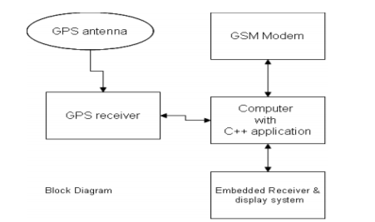

Figure 2. : GPS and GSM module

Once all the data is collected, it is stored on a cloud-platform like AWS which will act as a source of data fir the Machine learning model.

### 2.3.2 Machine Learning

Using the data generated by the IoT device and Sexual Violence Datasets from sources like Safecity analysis will be performed. The data goes through Pre Processing where ‘cleaning’ will be performed like removing the empty spaces and perform feature extraction of relevant columns.

Supervised learning is the technique used to map the data to the target variable (predicted output). Scikit-learn library will facilitate use packages like the numPY to enable data analysis. For the decision boundary technique to work the SVM algorithm is used, the inputs are divided into two classes, if results are above the decision boundary; it is match.

Figure 2. : Decision Boundary

□ □ □

□ □ □

■ ■ ■ ■ ■

■ ■ ■ ■

■ ■

PCA (Principal Component Analysis) will be used for prediction. A report will be generated based on the data, given that the Programming language used is Python.

## 2.4 Related Applications

The existing systems include;

### 2.4.1 ATHENA

It is a black silicone pendant, product of Olympus software, the size of a half-dollar and can be pinned to a purse, clothing, or even worn as a necklace. Depends on the user’s lifestyle. The device has a push (sunken) button at the centre to prevent accidental alerts, user holds it three seconds to prompt an alarm that will immediately inform/ notify the selected contacts of their live location, instead, if pressed three times in quick succession a silent alarm is sent, this is very useful when the users does not want to raise suspicion when she feels threated. (Anon., 2017)

Silent ROAR is mode sends a message without an alarm and Alarm Mode, which sounds an alarm to emergency contacts. Athena also has 911 calling capabilities and via the ROAR Personal Safety app, users also have access to self-defence videos, general safety awareness tips, and the latest news related to gender equality.

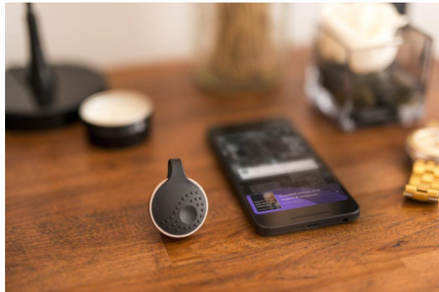

Figure 2. : ATHENA

### 2.4.2 Watch Over Me

This is a mobile application that allows the user to set a timer when they are travelling alone. The user has the ability to shake the phone in case they are unable to call someone, It works even when the phone is locked, after activating the application, the video camera and alarm are triggered, and an alert is sent to the enlisted contacts. The application notifies the user when they are approaching a high-[crime](https://www.psychologytoday.com/us/basics/law-and-crime) region.

The user can add updates in the like pictures. If the timer ends and the victim has not pressed the I’m safe button, the enlisted contacts are sent to the last known location and any information uploaded. The app is activated based on dormancy;

However, this technique is only limited to the information provided by the application; in case your phone is thrown away that can be used to disguise your last known location or if somebody steals the mobile phone.

Figure 2. : Watch Over Me

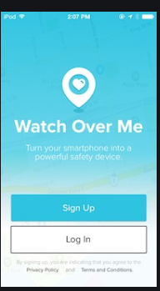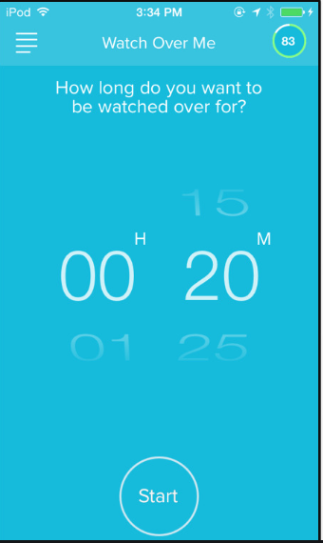

### 2.4.3 Safecity

This is an application that allows you to report harassment and feelings of threat on your location. There is a tracker function that allows you to track the enlisted contacts. Individuals share their personal stories of sexual harassment and abuse in public spaces, categorising them by place, time and type of harassment, other people using the software can see the regions with high cases and may avoid or be cautious of their location. Users can also upload photos and videos - any resource that can help them to share not only information, but also advice, and more importantly, support. (Bramley, 2015).

This application also allows anonymity, personal information like; occupation, email, location is highly protected unless the user decides to share. the organisation that runs the application has been able to identify location-based patterns and trends (using a machine learning model) where sexual violence crimes are committed.

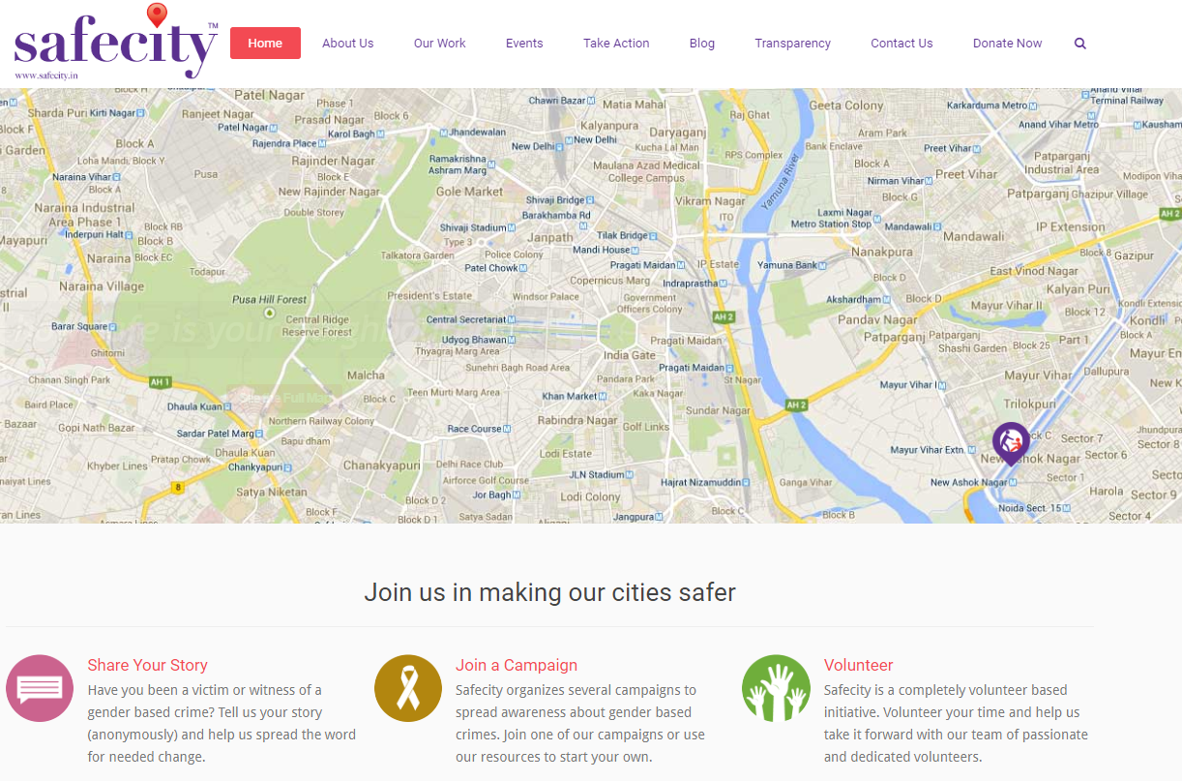

Figure 2. 5: Safecity

### 2.4.4 React Mobile app

React Mobile is a safety app synchronized with a button device that can be attached to car keys, clothing, wallets, or carried in hand. Once activated, a React Mobile transmitter immediately provides with your live location and profile details to the emergency contacts. React Mobile also offers group packages, perfect for organizations and community groups looking to stay protected together.

The application allows the user to save contacts that would be contacted in case of an emergency. There are three options: ‘I’m fine’ when the feels safe. ‘Follow me’ is selected when the user feels the need share their location, the location is live until a different option is selected. The location is shared through text and email. The last option being ‘Help Me’, 911 would be automatically contacted but, the user has ten seconds to cancel the call in addition to, the selected contacts would have received a message stating that you are in danger.

However, the application has available concerns there are times when it can’t load this would be very risky when you the user does not feel safe.

Figure 2. : React Mobile

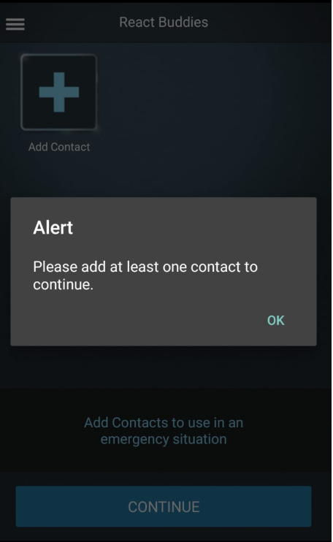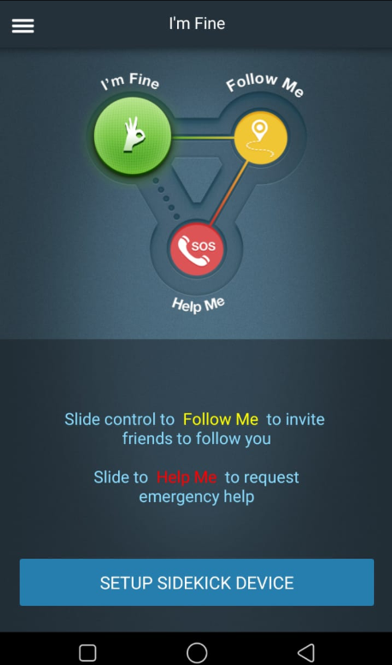

Figure 2.

### 2.4.5 Prevention Education

The education programs that have been that different adapted by different institutions to different types of age groups like teens and college students. The students’ normal curriculum won’t be interfered with, however, a lot of emphasis has been placed on prompting student participation rather than presenting an entirely instructive program this way the students get to grasp the idea on a deeper level. Programs for older students may include: Setting clear personal boundaries, developing healthy approaches toward emotional and sexual relationship and confronting sex role stereotypes.

The University of Michigan has a nationally known, full-fledged Sexual Assault Prevention and Awareness Centre that offers a wealth of services to the campus community. Their campus rape crisis centre provides peer education on rape prevention, organizes rape awareness weeks, and provides programs for men through the Men's Outreach Committee. (Joel Epstein & Langenbahn, 1994)

(Anon., 2019)

Figure 2. : RPE

### 2.4.6 SHE‐ Society Harnessing Equipment (IoT)

It is an attire embedded with an IoT electronic device. The attire can distribute an electric shock to attackers strong enough to cause severe burns, protecting the victim from any of the electricity. The garment is fixed with four sensors to detect the position of your fingers; a joystick, an accelerometer and four push buttons. A pressure sensor is connected to an electric circuit that electrocutes the perpetrator when it is squeezed forcefully, and the system is placed in a two-layer fabric, which prevents the victim from electric shock. (ZIKRIYA, et al., 2017)

The pressure measures or can differentiate actions like a grab or a pinch. The pressure applied on clasping cannot be quantified as a harmful action because it does not fulfil the conditions for activating the device.(Graham, 2013)

The sensors and buttons can put in way that is comfortable to the user. The user can manually activate the sensors in case she feels threatened and later linked to the mobile application or monitor.

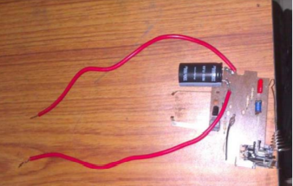

Figure 2. 8: SHE

## 2.5 Gaps in Existing Systems

The measures that Athena and react Mobile take, may not prevent offenders from harming other people. They do not inform the users on area that have had previous cases of sexual violence and they tend to be expensive so only a few can access the device and if the perpetrator happens to get hold of the device the victim becomes hopeless. There is no existing Machine Learning Model, being integrated by IoT, that has been developed that is similar to the one being proposed. The devices consume a lot charge; a backup battery would be efficient.

## 2.6 Conceptual Diagram

The conceptual diagram gives visual representation of how the proposed system is going to work.

Figure 2. : Conceptual diagram

Database

Database

IoT Integration

IoT Integration

ML model

ML model

Report

Report

Results

Results

Sensors

Sensors

# References

Minnesota Advocates for Human Rights, 2003. *What Is Gender-Based Violence?.* [Online]   
Available at: http://www.stopvaw.org

© National Sexual Violence Resource Cente, 2010. *The Impact of Sexual Violence.* [Online]   
Available at: www.nsvrc.org

ajdupree, 2014. *Instructables.* [Online]   
Available at: https://www.instructables.com/id/Arduino-Stress-Detector/  
[Accessed June 2020].

Anon., 2013. Justice and Gender-Based Violence. In: *Revue Internationale de Philosophie, Vol. 67, No. 265 (3), PHILOSOPHY AND VIOLENCE.* s.l.: Revue Internationale de Philosophie, pp. 259-275.

Anon., 2016. *TECHFASTER.* [Online]   
Available at: http://techfaster.com/stiletto-safety-device/

Anon., 2016. *Wangu Kanja Foundation.* [Online]   
Available at: https://wangukanjafoundation.org/

Anon., 2017. *10 Best Tech Devices to Prevent Rape.* [Online]   
Available at: https://www.psychologytoday.com/us/blog/the-body-blog/201704/10-best-tech-devices-prevent-rape

Anon., 2019. [Online]   
Available at: https://rpe.co.nz/

Anon., 2019. *Daily Nation.* [Online]   
Available at: https://www.nation.co.ke/news/Kilifi-leads-in-Kenya-incidence-of-rape/1056-5369726-28pfhfz/index.html

Anon., n.d. [Online]   
Available at: https://worldpopulationreview.com/world-cities/nairobi-population/

Anon., n.d. *LOYOLA University Maryland.* [Online]   
Available at: https://www.loyola.edu/department/counseling-center/students/concerns/sexual-assault/reactions  
[Accessed 21 June 2020].

Barr, C., 2019. *Thousands of rape reports inaccurately recorded by police.* [Online]   
Available at: https://www.theguardian.com/society/2019/sep/19/thousands-of-reports-inaccurately-recorded-by-police

Bigio, J. & Vogelstein, R., 2017. *Countering Sexual Violence in Conflict,* s.l.: Council on Foreign Relations.

Bramley, E. V., 2015. *The Guardian.* [Online]   
Available at: https://www.theguardian.com/cities/2015/aug/13/can-the-safecity-app-make-delhi-safer-for-women#:~:text=The%20Safecity%20app%20lets%20women,happened%20and%20when%20it%20happened%E2%80%9D.  
[Accessed 14 June 2020].

Centre, N. C. R., 2014. *GENDER BASED VIOLENCE IN KENYA,* Nairobi: s.n.

Graham, F., 2013. *BBC.* [Online]   
Available at: https://www.bbc.com/news/business-22110443  
[Accessed 14 June 2020].

Joel Epstein, E. & Langenbahn, S., 1994. *The Criminal Justice and Community Response to Rape ,* s.l.: National Institute of Justice. .

Jordan, C. E., Campbell, R. & Follingstad, D., 2010. Violence and Women’s Mental Health: The Impact of Physical, Sexual, and Psychological Aggression. july, p. 607–628.

LunesCuatro, 2019. *Instructables.* [Online]   
Available at: https://www.instructables.com/id/Blood-Pressure-Monitor/  
[Accessed June 2020].

Manzatto, A. A., 2019. *Medium.* [Online]   
Available at: https://medium.com/omdena/is-this-place-safe-274fc31c02c6  
[Accessed 19 June 2020].

mybotics, 2018. *Instructables circuits.* [Online]   
Available at: https://www.instructables.com/id/Pulse-Sensor-With-Arduino-Tutorial/  
[Accessed june 2020].

Parker, R. N. & Auerhahn, K., 1998. *ALCOHOL, DRUGS, AND VIOLENCE,* California: s.n.

Review, A., 2014. Sexual Violence and Its Discontents. 18 July, p. 139–154.

ZIKRIYA, M., G, P. M., MATH, S. R. & TANKASALI, S., 2017. *SMART GADGET FOR WOMEN SAFETY USING IoT,* BAGALKOT: BASAVESHWARA ENGINEERING COLLEGE.

# Appendix

Figure 2: : Gantt Chart Diagram

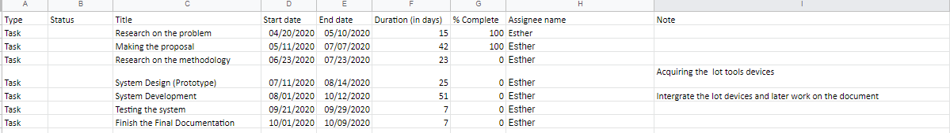

Figure 2: : Gantt Chart Table